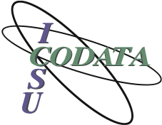 | 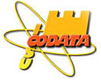 | 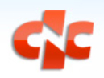 | 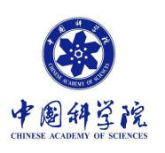
Application Form:
CODATA International Training Workshop in Open data for Better Science,
for Researchers from Countries with Developing or Emerging Economies
Computer Network Information Center, Chinese Academy of Sciences,
Beijing, China; 16-29 July 2017

Please complete the form below and send it, with an academic CV, to the addresses below by the deadline of 23.59 UTC on 25 April 2017:
Dr. Simon Hodson, Executive Director, CODATA | E-mail: simon@codata.org
Ms. LI Chang, CODATA-China Secretariat | E-mail: lichang@cnic.cn

Family Name: |  |  |  |  |  |  | Given Name:
Date of Birth: |  |  |  |  |  |  | Sex:
Nationality:
Academic Title/Position:
Area of Research:
Organization:
Address:
Tel: |  |  |  |  |  |  | Fax:
E-mail:
Education Degree:
Proficiency in English
Excellent: |  |  |  | Good: |  |  |  | Fair: |  |  | Poor:

Please provide a short statement (no more than a page in total) providing information on the following:
- What expertise would you bring as a participant?
- What specific subjects would you like to cover and how will this help you?
- How would you hope to apply the experience gained from the course in your own country?

